THE

BOULEVARD SHOPPING CENTER

LEASE AGREEMENT

This Lease Agreement (the “Agreement”) is entered into as of _June , 2023____, but effective for all purposes as of ___July 1, 2023___________ (the “Effective Date”), by and between:

BELLE REALTY OF LAFAYETTE, LLC, a Louisiana limited liability company, whose current mailing address is 101 Arnould Boulevard, Lafayette, Louisiana 70506 (hereinafter referred to as the “Lessor”);

and

______________________, a ____________________________, whose mailing address during the term of this Lease shall be __10099 N. Reiger Rd., Baton Rouge, LA 70809____, and who is being represented herein by its President and Chief Executive Officer, Katherine B. Trahan (hereinafter referred to as the “Lessee”).

WITNESSETH:

WHEREAS, Lessor is the owner of that certain real property together with improvements located thereon known as The Boulevard Shopping Center located in Lafayette, Lafayette Parish, Louisiana (“Boulevard Shopping Center Property”).

WHEREAS, Lessee wishes to lease a certain portion of the Boulevard Shopping Center Property from Lessor according to the terms and conditions set out herein.

NOW, THEREFORE, in consideration of the foregoing and other good and valuable consideration herein, the sufficiency of which is hereby acknowledged, the parties hereto agree as follows:

Section 1.01 – Premises:

- Lessor does hereby lease to Lessee, and Lessee hereby leases from Lessor the following premises, being more particularly described as follows:

Three Thousand Eight Hundred Thirty-Four (3,834) square feet located in the Boulevard Shopping Center Property as shown on the plat attached hereto as Schedule A and having the dimensions set forth thereon. Schedule A and having the dimensions set forth thereon. Said Premises has municipal addresses of 139 & 141 Arnould Boulevard, Lafayette, Louisiana 70506.

- Lessee warrants and represents that it has inspected the Premises and accepts the Premises, including the building and improvements, in its present state and without any representation or warranty by Lessor whatever as to the condition of the Premises. Lessor shall not be responsible for the condition of the Premises.

. Lessor makes no covenant, representation or warranty as to the suitability of the Premises for any purpose or use whatsoever or as to the physical conditions thereof. Lessee acknowledges that it has inspected the Premises, observed the physical characteristics, determined the compliance with requirements imposed by any governmental agency having jurisdiction over the Premises, and examined its existing conditions, and has had the opportunity to conduct such investigation and study on and of the Premises as it deems necessary for its intended use and occupancy under this Agreement. Lessee hereby waives any and all objections to or complaints about the physical characteristics and existing conditions of the Premises. Lessee further acknowledges and agrees that the Premises is being leased to, and accepted by Lessee in its present condition “AS IS” with all faults, and Lessee hereby assumes the risk that its adverse physical characteristics and existing conditions may not have been revealed by its inspection or investigation of the Premises. By taking possession of the Premises, Lessee accepts the Premises as suitable for the purpose for which the same is leased, and accepts the Premises and each and every acceptance thereof and Lessee, by said acts, waives any and all defects therein.

Section 2.01 - Use:

The Premises shall be used by Lessee during the term hereof as a Tag & Title, Driver’s License, and Notary Service business and general office space, and Lessee agrees that any change in the use of the Premises shall require the prior written consent of the Lessor.

Subject to the provisions of Section 2, and provided that: (a) this Lease has not been terminated; (b) Lessee is not in default of this Lease beyond applicable notice and cure periods; (c) Lessee opens to the public at the Premises for the permitted Use, Lessor agrees that it shall not voluntarily enter into any lease agreement giving a third party the right to operate in the Boulevard Shopping Center Property, a business whose primary business would be the same or similar to that of Lessee and which includes _________________________.

The prohibition shall not apply to: (a) any Lessee or successor to Lessee whose lease, including any renewal or extension, is in effect prior to the Effective Date.

Should any other Lessee or occupant at the Shopping Center violate the exclusive use rights granted to Lessee by this Section, Lessor shall take all reasonable and prudent actions necessary or desirable to be taken to cause the offending Lessee or occupant to cease its violation. Should, within a reasonable time after Lessee has given Lessor notice of an alleged breach thereof by such other Lessee or occupant, Lessor fail to proceed as provided in the previous sentence, Lessee, as its sole remedy, may proceed against that Lessee or occupant, in its own name, and at its own expense, to obtain injunctive relief against the offending Lessee and/or to obtain monetary damages from the offending Lessee or occupant, unless Lessor has failed to include Lessee’s exclusive in the offending Lessee’s lease, in which case Lessee may proceed against Lessor. Lessor agrees to cooperate with Lessee in any such action, but Lessee shall reimburse Lessor for any out-of-pocket expense incurred by Lessor in so doing.

The Premises shall be not be used during the Initial Term or any Renewal Term hereof as:

- A delicatessen or other restaurant whose operations are the same or similar to a Jason’s Deli or whose primary menu items are salads, soups, sandwiches, and baked potatoes or any one or more of said items.
- A veterinary clinic engaged primarily in the care and treatment of cats.
- A retail boutique for the sale of items including, but not limited to clothing, gifts, accessories, home goods, monogrammed and/or personalized items, candles, home decorations, drinkware, and jewelry.

Section 3.01 - Term:

The term of this Agreement shall commence on July 1, 2023 (“Commencement Date”) and shall expire at midnight, Lafayette, Louisiana time on July 31, 2026 (“Initial Term”).

Section 4.01 - Rent:

- Premises Base Rent. During the Initial Term, the Lessee shall pay to the Lessor a monthly base rent for the Premises, which is calculated as follows and depicted below in the column labeled “BASE”:

 | UNIT 139-149 | MONTH 1 | 3834
 | RENT ITEM | PER SQUARE FOOT | PER MONTH
 | BASE | $ 0.00 | $ 0.00

 | UNIT 139-149 | MONTH 2-37 | 3834
 | RENT ITEM | PER SQUARE FOOT | PER MONTH
 | BASE | $ 13.50 | $ 4313.25

- Additional Rent. During the Initial Term, the Lessee shall pay to the Lessor, as additional rent (“Additional Rent”), the following amounts.

  - Common Area Maintenance Charges. The Lessee shall pay to the Lessor, the Lessee’s Pro Rata Portion of the Common Area (as hereinafter defined) maintenance charges (“Common Area Maintenance Charges”). The Common Area Maintenance Charges shall mean the aggregate of all costs and expenses payable by Lessor in connection with the operation and maintenance of the Common Area in the Boulevard Shopping Center Property, including but not limited to landscaping costs, parking area maintenance costs (including repairing, resurfacing, cleaning and striping), utility costs (including water, sewer, electricity and gas), security system costs, life and safety systems costs, electronic monitoring system costs, compensation (including employment taxes and benefits) of all persons who perform duties connected with the operation and maintenance of the Common Area and any other reasonable costs incurred by the Lessor with respect to the Common Area and not otherwise reimbursed by the Lessee hereunder. Common Area shall mean all areas, space, equipment and special services provided by the Lessor for the common or joint use and benefit of the Lessee and other tenants, their employees, agents, servants, suppliers, customers and other invitees, including but not limited to retaining walls, fences, landscaped areas, parking areas, curbs, driveways, sidewalks, private roads, green spaces, landscape areas, patios, service areas and all common areas and other areas all as shown on the site plan attached hereto as Schedule B.

  - Tax and Insurance Charges. The Lessee shall pay to the Lessor the Lessee’s Pro Rata Portion of the annual charges incurred by the Lessor for taxes and insurance coverage for the Boulevard Shopping Center Property (“Taxes and Insurance Charges”). Tax charges shall include all real property taxes, personal property taxes, improvement bonds and other charges or assessments which are levied upon or with respect to the Boulevard Shopping Center Property, including any increase in such taxes or a reassessment of the value of the Boulevard Shopping Center
Property, license fees, or other taxes or fees levied in connection with the Lessor's leasing or rental of the Boulevard Shopping Center Property, but shall not include any federal or state income tax imposed upon the Lessor. Insurance charges shall include the cost of any insurance obtained by the Lessor in connection with the Boulevard Shopping Center Property, including but not limited to fire, casualty and liability insurance policies.

  - Payment of Additional Rent. Beginning on August 1, 2023, and continuing on the first day of each calendar month thereafter, the Lessee shall pay to the Lessor, as Additional Rent, one twelfth of the Lessee’s Pro Rata Portion of the Common Area Maintenance Charges and one twelfth of the Lessee’s Pro Rata Portion of the Taxes and Insurance Charges as set forth herein. The parties agree that the Common Area Maintenance Charges for the period beginning on August 1, 2023 is $2.10 per square foot of the Premises annually, payable monthly as provided herein. The parties agree that the Taxes Charges for the period beginning on August 1, 2023 is $0.95 per square foot of the Premises annually, payable monthly as provided herein. The parties agree that the Insurance Charges for the period beginning on August 1, 2023 is $1.95 per square foot of the Premises annually, payable monthly as provided herein

The Total Monthly Rental Payment Amount for months one (1) through thirty-six (37) of the Initial Term for the Premises shall be calculated as follows:

 | UNIT 139-149 | MONTH 1 | 3834
 | RENT ITEM | PER SQUARE FOOT | PER MONTH
 | BASE | $ 0.00 | $ 0.00
 | CAM | $ 0.00 | $ 0.00
 | Taxes | $ 0.00 | $ 0.00
 | Insurance | $ 0.00 | $ 0.00
 | TOTAL | $ 18.50 | $ 0.00

UNIT 139-149 | MONTH 1-37 | 3834
RENT ITEM | PER SQUARE FOOT | PER MONTH
BASE | $ 13.50 | $ 4313.25
CAM | $ 2.10 | $ 670.95
Taxes | $ 0.95 | $ 287.55
Insurance | $ 1.95 | $ 623.03
TOTAL | $ 18.50 | $ 5,910.75

Notwithstanding anything contained herein to the contrary, beginning in the second year of the Initial Term, Lessor may, if, in Lessor’s discretion, the same is necessary to cover an increase in Taxes and Insurance charges, increase the amount of the Common Area Maintenance Charges and/or Taxes and Insurance Charges for any calendar year thereafter by providing written notice of the same to the Lessee; provided, however that any such increase shall not exceed the prior calendar year actual Common Area Maintenance Charges and/or Taxes and Insurance Charges by more than five percent (5%).

4. Payment of Rent. The monthly payment of the Base Rent and Additional Rent for the Premises (collectively, the “Total Monthly Rental Payment”) shall be due on the first day of each calendar month. The Lessor and Lessee hereby acknowledge and agree that the Lessee shall be obligated to make monthly Additional Rent payments beginning with the Commencement Date.

In the event the Lessor does not receive the Total Monthly Rental Payment on or before the fifth day of the calendar month, a late fee in the fixed amount of $100.00 plus a daily charge beginning on the sixth day of the calendar month in the amount of $25.00 per day shall be charged and shall be due and payable by the Lessee for each late payment.

All rental payments due hereunder shall be made to the Lessor by mailing the same to 101 Arnould Boulevard, Lafayette, Louisiana 70506 or such other place, as the Lessor shall designate in writing. Notwithstanding the foregoing, Lessor shall have the right to require at any time during the Initial Term that the Total Monthly Rental Payment and any other payments due to Lessor be paid to Lessor via electronic funds transfer, automatic wire transfer, ACH payment transfer, or other automated electronic payment method for deposit into and credit to a bank account designated in writing by Lessor.

Section 5.01 - Real Property Taxes:

Lessee shall be responsible for and shall pay before delinquency, its Pro Rata Portion of all real property taxes and assessments levied and assessed against the Premises, and shall make such payment in accordance with paragraph 4.01(B) hereof.

Section 6.01 - Personal Property Taxes:

Lessee shall be responsible for and shall pay, before delinquency, all taxes, assessments, license fees, and other charges that are levied and assessed against Lessee’s personal property installed or located in or on the Premises, and that become payable during the Initial Term or any renewal thereof.

Section 7.01 - Limitations on Use:

Lessee shall not do, bring or keep anything in or about the Premises that will cause the cancellation of any insurance covering the Premises. If the rate of any insurance carried by Lessor is increased, as a result of Lessee's use, Lessee shall reimburse Lessor for the amount of such increase.

- Lessee shall not permit any activity on the premises which may in law constitute a nuisance, public or private, or which may constitute a violation of any environmental laws, or any other laws, ordinances or regulations.

- Lessee shall not operate all or any portion of the premises as a “place of public accommodation,” as such term is defined under the Americans With Disabilities Act, 42 U.S.C. 12101 et, seq. (the ADA) and the regulations pursuant to such act.

Section 8.01 - Assignment and Subletting:

Lessee shall not sell, mortgage, transfer, assign or sub-let all or any portion of the Premises without the prior written consent of the Lessor, which consent shall be in the sole discretion of the Lessor. Provided however, the Lessor shall not be obligated to consent to any assignment, transfer or sub-let in the event the proposed transferee’s use of the Premises would be in conflict with the provisions of any other lease in the Boulevard Shopping Center Property. Further provided, that in no event shall Lessor's consent to an assignment or subletting by construed as (i) relieving Lessee from the obligation to obtain Lessor's express written consent to any further assignment or subletting or (ii) releasing Lessee from any liability or obligation hereunder whether or not then accrued, and Lessee shall continue to be, fully, jointly and severally liable hereunder. The Lessor may sell, mortgage, transfer or assign its interest in this Agreement at any time without the consent of the Lessee, but such transaction(s) shall be made subject to rights of Lessee under this Lease.

Section 9.01 - Maintenance, Repairs:

Lessee acknowledges that the Premises is in good order and repair and shall surrender the same at termination hereof, in as good condition as received, normal wear and tear excepted. Lessee shall be responsible for all repairs required, excepting the roof, exterior walls and structural foundation (including the electrical and plumbing systems situated in or below the Premises’ concrete slab foundation), which shall be maintained by Lessor. Lessee shall also be responsible for keeping at all times areas immediately adjacent to the Premises, such as sidewalks and parking areas, free and clear of trash and other refuse. Lessee shall promptly repair any damage to any part of the building in which the Premises is located, including but not limited to the roof, exterior walls and structural foundation (including the electrical and plumbing systems in or below the Premises’ concrete slab foundation), in the event such damage is caused by or attributable to the actions or inactions of Lessee, its employees, officers, directors, shareholders, members, partners, representatives, agents, customers, guests, invitees or licensees, to the extent to which such is not covered by insurance under Section 15.01. Notwithstanding the foregoing, the Lessor shall be responsible for the repair and replacement, if necessary, of the heating and air conditioning (“HVAC”) system servicing the
Premises provided that (i) the Lessee shall pay the first $1,500.00 for each repair visit and fifty-percent (50%) toward the replacement cost of the HVAC system or any component thereof, and (ii) the Lessee maintains, at its own expense, for the full term of this Agreement and any renewal or extensions thereof, a monthly maintenance contract with Butcher Air Conditioning for regular routine maintenance to the HVAC systems and components thereof in the Premises. Further provided, in the event it is determined by the HVAC maintenance provider that the HVAC systems or any component thereof must be replaced and such replacement is made within fifteen (15) days of a repair visit made by such HVAC maintenance provider (“Preceding Repair Visit”) (not including a routine maintenance visit pursuant to a monthly maintenance contract), then the amount paid by the Lessee toward the cost of the Preceding Repair Visit shall be credited toward the Lessee’s obligation to pay fifty-percent (50%) toward the replacement cost of the HVAC system.

Lessee further agrees to maintain the Premises in clean and healthful condition and to comply with all laws, ordinances, orders, rules and regulations (state, federal, municipal and any other agencies or bodies having any jurisdiction thereof) with respect to the use, condition or occupancy of the Premises.

In discharging the responsibilities hereunder, Lessee shall utilize the services of bonded, licensed contractors to perform all maintenance or repair work to the Premises.

Lessee agrees to hire Butcher Air Conditioning, or other agreeable HVAC provider, to perform all maintenance, repairs and replacements of the heating and air conditioning systems and components servicing the Premises.

Section 10.01 - Alterations:

Lessee shall not make any additions, improvements or alterations, structural or otherwise, to the Premises without Lessor’s written consent, which consent shall be in the sole discretion of the Lessor. In making any improvements, additions or alterations that require the consent of Lessor, Lessee, after obtaining Lessor’s consent, shall comply with the following:

- The improvements or alterations shall not be commenced until seven (7) days after Lessor has received written notice from Lessee stating the date the alternations are to commence and Lessor has consented to same.

- The improvements or alterations shall be in conformance with all applicable local, state or federal laws and regulations.

Lessee shall have the duty, only if Lessor so requests in writing, to remove from the Premises before the expiration of the term, or within fifteen (15) days after the expiration of the term, any additions, improvements or alterations Lessee has made to the Premises, so long as the removal will not cause structural damage to the Premises, and Lessee, at its cost, shall promptly restore any damage caused by the removal and return the Premises to the condition it was in at the beginning of the Initial Term.

The Lessee shall not cause or permit any mechanic’s liens to be filed against the Premises, and Lessee shall indemnify, hold harmless, and defend the Lessor from and against any and all such liens.

Moreover, any additions, alterations and improvements made by Lessee, with or without consent of the Lessor, no matter how attached to the Premises, shall remain the property of the Lessor unless otherwise stipulated herein, and Lessee expressly waives any right to compensation or reimbursement for any such additions, alterations or improvements which may be made on the Premises. Notwithstanding the above, however, Lessee may remove from the Premises its office supplies, movable office furniture and movable equipment not attached to the Premises provided (a) such removal is made prior to the termination of the term of this Agreement; (b) Lessee is not in default of any obligation or covenant under this Agreement at the time of such removal; and (c) Lessee promptly repairs all damage, no matter how slight, caused by the installation, use or removal of such furniture or equipment. Furthermore, Lessee, or any of its hired architects, engineers, contractors, subcontractors or employees, shall not remove or discard any thing or any item, furniture, fixture, flooring, movable or immovable, etc., without first consulting the Lessor and obtaining Lessor’s written permission.

Section 11.01 - Utilities and Janitorial Services:

Lessee shall pay before same becomes delinquent, all utility and service charges for utilities or services furnished to the Premises or used by the Premises or the Lessee, including, without limitation, electricity, gas, water, telephone service and trash collection. Lessee shall be responsible for maintaining the Premises in accordance with the terms hereof and shall be responsible for the payment of any costs or expense with respect to any janitorial services provided to the Premises, and Lessee shall be responsible for the trash or refuse disposal services to the trash or refuse generated by or related to the Premises.

At the commencement of the Initial Term, Lessee shall immediately transfer electric utility service from the name of Lessor to the name of Lessee. If the Lessee fails to immediately transfer electric utility service to the name of Lessee, Lessor may, at its discretion, (i) direct the electric utility provider to discontinue service to the Premises in Lessor’s name, or (ii) make electric utility payments on behalf of Lessee and require that Lessee remit to Lessor full reimbursement for such payments together with a $100.00 administrative fee for each payment required to be made by Lessor.

Lessee shall not disconnect the electricity, gas or water at any time during the term of this Agreement, including in anticipation of the termination of the tenancy created herein. Upon termination of the term of this Agreement, or in anticipation thereof, Lessee shall give Lessor reasonable written notice of its intent to disconnect electricity, gas and/or water service. Upon receipt of written notice to disconnect, Lessor may require, in its sole discretion, that Lessee cooperate with Lessor and do all things necessary to allow such utilities to be transferred into Lessor’s name prior to disconnection.

Section 12.01 - Signs:

Lessee, at its cost, shall have the right to place, construct and maintain an exterior sign on the Premises advertising its business conducted on the Premises. Such sign shall be located on the front exterior wall of the Premises above the front canopy extending from the front wall. Lessor shall have the right to approve such signs prior to their placement on the Premises, which approval shall not be unreasonably withheld, and any sign that Lessee has the right to place, construct and maintain shall comply with all applicable laws or regulations including, but not limited to the rules and regulations attached hereto as Schedule C and the design criteria attached hereto as Schedule D. Upon termination of the tenancy herein created, Lessee shall remove any sign so placed and repair any damage or injury to the Premises or the exterior thereof caused by such removal, and Lessee shall retain the contractor designated by Lessor to repair the damage caused by such removal. In the event the Lessee does not remove its sign as provided herein, then the Lessor shall have the right to remove the sign or signs and the Lessee shall be responsible for the payment of such removal and such cost or expense shall be considered as rent due hereunder.

In addition, Lessee must obtain prior written approval from Lessor of all Lessee exterior signage.

Should Lessee choose to place a sign under the Premises walkway, it must be erected by Hubbard Sign Company and paid for by the Lessee.

Section 13.01 - Access:

Lessor and its authorized representatives shall have the right after twelve (12) hours notice to Lessee, to enter the during Lessee’s business hours and at all other reasonable times with such prior notice for the purpose of:

- Determining whether the Premises is in good condition and whether Lessee is complying with its obligations under this Agreement;

- Doing any necessary maintenance and to make any restoration or repair to the Premises or the building and other improvements in which the Premises is located that Lessor has the right or obligation to perform.

- Posting “for rent” or “for lease” signs during the last three (3) months of the term of this Agreement or any renewal thereof.

Section 14.01 –Indemnity:

Lessee shall hold Lessor harmless from all damages arising out of any loss, theft, injury or damage to any person or property (as the case may be) occurring in, on, or about the Premises except for damages resulting from the gross negligence or willful conduct of Lessor. Lessee shall be liable to Lessor for damages resulting from the acts or omissions of Lessee, its employees, officers, directors, shareholders, members, partners, representatives, agents, customers, guests, invitees and licensees or of Lessee's, its employee’s, officer’s, director’s, shareholder’s, member’s, partner’s, representative’s, agent’s, customer’s, guest’s, invitee’s and licensee’s negligence, gross negligence or willful conduct. Lessee’s obligation under this paragraph to indemnify and hold the Lessor harmless shall be limited to the sum that exceeds the amount of insurance proceeds, if any, received by the Lessor. The indemnitee shall give prompt notice to the indemnitor of any claim to which this indemnity applies.

Section 14.02 - Hazardous Substances:

Lessee warrants and covenants that neither the Lessee, nor its employees, agents, officers, shareholders, partners, members, invitees, guests or customers shall use, deposit, store, transport, locate, bring on to or cause to be brought on to the Premises any Hazardous Substances and further warrants and covenants that neither Lessee nor employees, agents, officers, shareholders, partners, members, invitees, guests or its customers shall release, discharge, spill, dispose, emit or permit the breakage of, Hazardous Substances in, on or under the Premises.

Lessee agrees to indemnify and hold harmless Lessor from any and all claims, damages, fines, judgements, penalties, costs, liabilities, or losses (including, without limitation, any and all sums paid for settlement of claims, attorneys' fees, consultant and expert fees) arising during or after the term of this Agreement or any renewal hereof from or in connection with the presence or suspected presence of Hazardous Substances in or on the Premises, which Hazardous Substances were brought onto the Premises during the term of this Agreement or any renewal thereof by the Lessee, its agents, officers, representatives, employees, invitees or licensees or become deposited or otherwise become present on the Premises during the term of this Agreement or any renewal thereof. Without limiting of the foregoing, this indemnification shall include any and all costs incurred due to any investigation of the site or any cleanup, removal, or restoration mandated by a federal, state, or local agency or political subdivision.

For purposes of this section, the term "Hazardous Substances" shall be interpreted broadly to include, but not be limited to, substances designated as hazardous under the Comprehensive Environmental Response, Compensation and Liability Act of 1980, as amended, 42 U.S.C. 9601, et seq., the Resource Conservation and Recovery Act, 42 U.S.C. 2201, et seq., and any applicable State or federal law or regulation. The term shall also be interpreted to include but not be limited to any substance which after release into the environment and upon exposure, ingestion, inhalation or assimilation, either directly from the environment or directly by ingestion through food chains will or may reasonably be anticipated to cause death, disease, behavior abnormalities, cancer and/or genetic abnormalities, and oil and petroleum based derivatives.

The provisions of this section shall be in addition to any other obligations and liabilities Lessee may have to Lessor at law or in equity and shall survive the termination of this Agreement.

Section 15.01 - Insurance:

Lessee, at its cost, shall maintain comprehensive general liability insurance in a minimum amount of $1,000,000.00 for each occurrence with a $1,000,000.00 general aggregate, including $1,000,000.00 personal and advertising coverage, $100,000.00 in fire legal liability, and $5,000.00 in medical payments, insuring against all liability of Lessee arising out of and in connection with Lessee's use or occupancy of the Premises. All such insurance policies shall name the Lessor as an additional insured. At the Commencement Date and on each anniversary date of the Commencement Date, Lessee shall supply to Lessor a certificate that such insurance is in force and the requisite premiums have been paid. Lessee's insurance policies and coverage shall be endorsed to apply on a primary basis. It is further provided that Lessee's insurance policies and coverage shall contain (either directly in the policy or by endorsement) a provision that provides that the Lessor shall be entitled to thirty (30) days prior written notice of cancellation and/or non renewal of such policy or coverage of the Lessee.

Lessor shall maintain fire, casualty and extended coverage insurance on the Boulevard Shopping Center Property and improvements thereon, and upon written request from the Lessee, the Lessor shall supply to Lessee a certificate establishing that such insurance is in force and the requisite premiums have been paid.

Section 16.01 - Waiver of Subrogation:

To the extent that a loss is covered by insurance in force and recovery is made for such loss, the Lessor and Lessee hereby mutually hold harmless and release each other from liability and waive all right of subrogation against each other for any loss or damage to their respective properties. Each party shall cause each insurance policy obtained by it to provide that the insurance company waives all right of recovery by way of subrogation against either party in connection with any liabilities or damage covered by any policy.

Section 17.01 - Damage or Destruction:

If the Premises is so damaged or destroyed by fire, flood, earthquake, the elements, casualty, war, riot, public disorder, acts authorized or unauthorized by the government (including a condemnation proceeding) or any other cause or happening so as to render the Premises unusable for Lessee's operations, as determined by the Lessor acting in good faith and in a commercially reasonable manner, this Agreement shall terminate immediately, and any unearned rent paid by Lessee shall be refunded without demand, setoff or reduction as of the date of such destruction or damage. However, there shall be no termination and no refund of unearned rent, except to the extent provided for or compensated for by Lessor’s insurance, paid by Lessee, if the damage is caused by the negligence, willful misconduct or gross negligence of Lessee, its employees, officers, directors, shareholders, members, partners, representatives, agents, customers, guests, invitees or licensees.

If the Premises is partially damaged or rendered partially unusable by fire or other casualty, as set forth above in the immediately preceding paragraph, Lessee shall give Lessor written notice of the damage and if repairs are not undertaken by the Lessee within thirty (30) days from the date of such notice to Lessor, Lessor may terminate this Agreement by giving written notice to the Lessee. If Lessor elects not to terminate, this Agreement shall continue in full force and effect and the damages to the Premises shall be repaired by and at the expenses of Lessee, except to the extent provided for or compensated for by Lessor’s insurance. Moreover, until such repair is substantially completed so that full use and occupancy of the Premises by Lessee is possible, the rent shall be apportioned according to the portion of the Premises which remains usable. If such repairs are not completed within one hundred eighty (180) days from the date of written notice of the casualty to Lessor, the Lessor may terminate this Agreement by the giving of written notice to the other party within ten (10) days of the expiration of the 180-day period.

If the building in which the Premises is located, or any portion thereof, provided such damaged portion contains all or a portion of the Premises, is partially damaged or rendered partially unusable by fire or other casualty as set forth above, as determined by the Lessor acting in good faith and in a commercially reasonable manner, Lessor shall undertake the repair of the building and the Premises (except if such damage is caused by the negligence, willful misconduct or the gross negligence of the Lessee, its employees, officers, directors, shareholders, members, partners, representatives, agents, customers, guests, invitees, or licensees, in which case the Lessee shall be responsible for the repair of the building and the Premises, except to the extent provided for or compensated for by Lessor’s insurance) within thirty (30) days from the date of the damages. This Agreement shall continue in full force and effect during the period of the repair and/or until this Agreement is terminated as provided herein. Moreover, until such repair is substantially completed so that full use and occupancy of the Premises by the Lessee is possible, the rent shall be apportioned according to the portion of the Premises remaining usable. If such repairs are not completed within one hundred eighty (180) days from the date that the repair work is began, either party may terminate this Agreement by giving written notice to the other party within ten (10) days of the expiration of the 180 day period.

Section 18.01 – Lessee’s Default:

The following events shall be deemed to be events of default by Lessee under this Agreement:

- Lessee shall be adjudged bankrupt, or shall file a voluntary petition in bankruptcy or make a general assignment for the benefit of Lessee's creditors, or a receiver by appointed for Lessee's property, or if execution be issued against Lessee's interest in this Agreement, or if Lessee's interest in this Agreement shall by operation of law pass to any person other than Lessee; or

- Lessee shall fail to pay the rental due hereunder or any other amount payable to Lessor hereunder; or

- Lessee shall fail to conduct business operations on the Premises and/or shall demonstrate other indicia of abandonment in such a manner that results in Lessor’s reasonable belief that Lessee has abandoned or vacated the Premises; or

D. Lessee shall fail to perform any requirements of this Agreement, other than a failure described in subsection 18.01(B) or 18.01 (C) above, and such failure shall continue for five (5) days after written notice of such failure from Lessor delivered to Lessee.

Upon the occurrence of any one or more of such events of default, at the option of Lessor, (i) this Agreement shall cease and terminate immediately and Lessee shall quit and surrender the Premises to Lessor, or (ii) Lessor may pursue any remedy available to Lessor, whether by law or contract, or in equity, including without limitation the repossession of the Premises by Lessor, in which event Lessee shall be liable for all rent payable through the date of repossession. If this Agreement shall have been terminated by Lessor pursuant to this Section 18.01, Lessor may at any time thereafter resume possession of the Premises by any lawful means, and remove Lessee and Lessee’s property therefrom. Time is of the essence with respect to all matters described in this Section 18.01.

Section 19.01 – Lessor’s Default:

Lessor shall be in default of this Agreement if it fails or refuses to perform any provision of this Agreement that it is obligated to perform if the failure to perform is not cured within thirty (30) days after written notice of the default has been given by Lessee to Lessor. If the default cannot reasonably be cured within thirty (30) days, Lessor shall not be in default of this Agreement if Lessor commences to cure the default within the thirty-day period and in good faith continues to cure the default. In the event the Lessor fails to cure a default as provided hereinabove and the continuance of such default results in the interruption of the Lessee's peaceable enjoyment of the Premises, then the Lessee shall be entitled to the abatement of the monthly rent payable under this Agreement and the amount of such abatement shall be in the same proportion as the amount of the Premises rendered unusable by Lessor's default is to the totality of the Premises.

Section 20.01 - Surrender of Premises:

Upon termination of this Agreement by lapse of time or otherwise, Lessee shall immediately surrender the Premises in as good condition as it was in at the beginning of the Initial Term, ordinary wear and tear and alterations, changes and additions made in compliance with this Agreement, acts of God, and other casualty excepted. In the event the Lessee retains possession of the Premises without exercising its option to renew in accordance with the terms of this Agreement and after the termination date of this Agreement, then the Lessee shall pay to the Lessor a monthly rental amount equal to 200% of the monthly rental amount set forth in Section 4.01 hereof for each month or part thereof that the Lessee retains possession of the Premises after the termination date of this Agreement.

Section 21.01 - Notice:

Any notice, demand, request, or consent that either party describes or is required to be given hereunder shall be in writing and shall be deemed sufficient if sent by United States first class mail, return receipt requested, Federal Express, or UPS:

LESSOR: BELLE REALTY OF LAFAYETTE, LLC
101 Arnould Boulevard
Lafayette, Louisiana 70506

LESSEE: __________________________
_10099 N. Reiger Rd.________________
_Baton Rouge, LA 70809___________

Either party may notify the other in writing of any different address for notice purposes.

All such notices shall be deemed given on the date of receipt at the applicable address as evidenced by the return receipt and/or delivery confirmation.

Section 22.01 - Common Area, Non-Exclusive Cross Use Easement and Parking:

Lessor shall have the sole and exclusive control of the Common Area as well as the right to make changes to the Common Area. However, notwithstanding the foregoing, Lessor shall not be responsible for any harm or damage to the Lessee, its offices, employees, shareholders, agents or invitees as a result of the use by any person or persons of the Common Area. Lessor's rights with respect to the Common Area shall include, but not be limited to, the right to (i) restrict the use of the Common Area by unauthorized persons (ii) utilize from time to time any portion of the Common Area for promotional and related matters, (iii) temporarily close any portion of the Common Area for repairs, renovations, alterations or otherwise (iv) limit the activities or uses of the Common Area by the Lessee, its agents, invitees, and employees.

Each lessee of the Boulevard Shopping Center Property shall have a non-exclusive right to use and enjoy the Common Area, subject to the provisions contained in this Agreement. Provided however, in no event shall there be any overnight parking or storage of any boats, automobiles, trucks, recreational vehicles, campers or trucks larger than those having six wheels on the Boulevard Shopping Center Property. In addition, no lessee shall perform or permit to be performed any maintenance on any vehicles in the Common Area. All delivery vehicles owned and operated by any lessee in connection with its business located in the Boulevard Shopping Center shall be parked at all times, during business and non-business hours in the rear of the lessee’s leased premises.

Section 23.01 - Interpretation:

This Agreement shall be construed and interpreted in accordance with the laws of the State of Louisiana.

Section 24.01 - Waiver:

No delay or omission by either party in exercising any right occurring upon any noncompliance or default by the other party with respect to any of the terms hereof shall impair any such or be construed to be waiver thereof. A waiver by either party of any of the covenants and agreements to be performed by the other shall not be construed to be a waiver of any succeeding breach thereof or of any other covenants or agreements herein contained.

Section 25.01 - Heirs and Successors:

Subject to the provisions hereof pertaining to assignment and subletting, the covenants and agreements of this Agreement shall be binding upon the heirs, legal representatives, successors and assigns of the parties hereto.

Section 26.01 - Integrated Agreement; Modification:

This Agreement contains all of the agreements of the parties and cannot be amended or modified except by a written agreement signed by the Lessor and the Lessee.

Section 27.01 - Recordation:

This Agreement shall not be recorded, except that if either party requests the other party to do so, the parties shall execute a memorandum of lease in recordable form.

Section 28.01 - Captions:

The captions used in this Agreement shall have no effect of its interpretation.

Section 29.01 - Severability:

The unenforceability, invalidity, or illegality of any provision of this Agreement shall not render the other provisions unenforceable, invalid or illegal.

Section 30.01 - Attorney's Costs:

If by reason of any default on the part of Lessee, Lessor retains an attorney to enforce the provisions of this Agreement and/or to notify Lessee of its default, Lessor shall be liable to Lessee for Lessor’s reasonable attorney’s fees and costs associated with such enforcement and/or notification and shall pay such fees and/or costs, including the cost of delivering notice of default, within thirty (30) days of receipt of written notice of the amount of such attorney’s fees and/or costs incurred by Lessor. If by reason of any default on the part of Lessee, Lessor shall bring suit to recover any rent due hereunder, or for breach of any provision of this Agreement or to recover possession of the Premises, or if Lessee shall bring any action for any relief against Lessor, declaratory or otherwise, arising out of this Agreement, the prevailing party shall have and recover against the other party in addition to the costs allowed by law, such sum as the court may judge to be a reasonable attorney's fee.

Section 31.01 - Option to Renew:

Provided that Lessee is not in default in the performance of this Agreement, Lessee shall have the option to renew the lease for one (1) additional term of three (3) years, commencing on the next day following the expiration of the Initial Term. All of the terms and conditions of this Agreement shall apply during the renewal term except that the Monthly Rental Amount shall be negotiated by the Lessor and the Lessee. The option to renew shall be exercised by written notice given to Lessor by Lessee not less than sixty (60) days prior to the expiration of the Initial Term. If notice is not given in the manner provided herein and within the time specified, this option to renew shall terminate.

Section 32.01 – Subordination:

- This Agreement is subject and subordinate to any mortgage which now or hereafter encumbers or affects the building of which the Premises form a part and/or the leasehold interest or fee simple interest of the Lessor in the land upon which the building is situated, and to all renewals, modifications, consolidations, replacements and extensions thereof. This clause shall be self-operative and no further instrument of subordination need by required by any mortgagee of Lessor. In confirmation of such subordination, however, Lessee shall, at Lessor’s request, promptly execute any appropriate certificate or instrument that Lessor may request. Lessee hereby constitutes and appoints Lessor as Lessee’s attorney in fact to execute any such certificate or instrument for and on behalf of Lessee. In the event of the enforcement by the holder of any such instrument of the remedies provided for by law or by such mortgage, Lessee will, upon request of any person or party succeeding to the interest of Lessor as a result of such enforcement, automatically become the lessee of such successor in interest without change in the terms or other provisions of this Agreement. Upon request by such successor in interest, Lessee shall execute and deliver an instrument or instruments confirming the attornment herein provided for.

- At Lessor’s request, Lessee will execute either an estoppel certificate or a three-party agreement certifying such facts and agreeing to such notice provisions and other matters as may reasonably be required.

Section 33.01 – Intentionally Omitted

Section 35.01 – Security Deposit:

Lessee has paid Lessor at the execution hereof the sum of $4,313.25 (the “Security Deposit”) as security for its performance of the terms hereof by Lessee. Provided Lessee is not in default of this Agreement, the Security Deposit shall be returned to Lessee within thirty (30) days after termination of this Agreement if, based on a good faith determination by Lessor, Lessee has fully discharged its obligations to Lessor pursuant to this Agreement in full. The Security Deposit may not be used by Lessee as the last month’s rent at the termination of this Agreement.

Section 36.01 – Rules and Regulations:

The Lessee agrees that during the initial term of this Agreement and any renewal thereof, to fully abide by and comply with the Rules and Regulations of the Boulevard Shopping Center attached hereto as Schedule C, as the same may be amended from time to time by the Lessor.

Section 37.01 – Design Criteria For Lessee Signs:

The Lessee agrees that any sign placed on or otherwise affixed to the Premises or to the Shopping Center advertising the Lessee’s business shall be in strict accordance with this Agreement and Schedule D attached hereto.

Section 38.01 – Confidentiality:

The Lessor and Lessee agree that the terms and conditions set forth herein are confidential information and neither the Lessor nor the Lessee shall make available to the public or any person not at party to this Agreement, by written or oral communication, the terms, conditions or substance of this Agreement or the lease set forth herein.

[SIGNATURES APPEAR ON THE FOLLOWING PAGES]

List of Schedules:
Schedule A – Plat of Leased Premises
Schedule B – Site Plan of Common Area
Schedule C – Rules & Regulations
Schedule D – Design Criteria for Lessee Signs

IN WITNESS WHEREOF the parties hereto have executed this Agreement the day and year first above.

WITNESSES: LESSOR:

BELLE REALTY OF LAFAYETTE, LLC,
Printed Name: a Louisiana limited liability company

By:

Printed Name: _______________________________

_______________________________

_________________________________
Notary Public

IN WITNESS WHEREOF the parties hereto have executed this Agreement the day and year first above.

WITNESSES: |  |  | LESSEE:
__________________,
Printed Name: a _____________________

By:

Printed Name: _______________________________

_______________________________

_________________________________
Notary Public

SCHEDULE A

BOULEVARD SHOPPING CENTER PROPERTY PLAT

SHOWING PREMISES LEASED
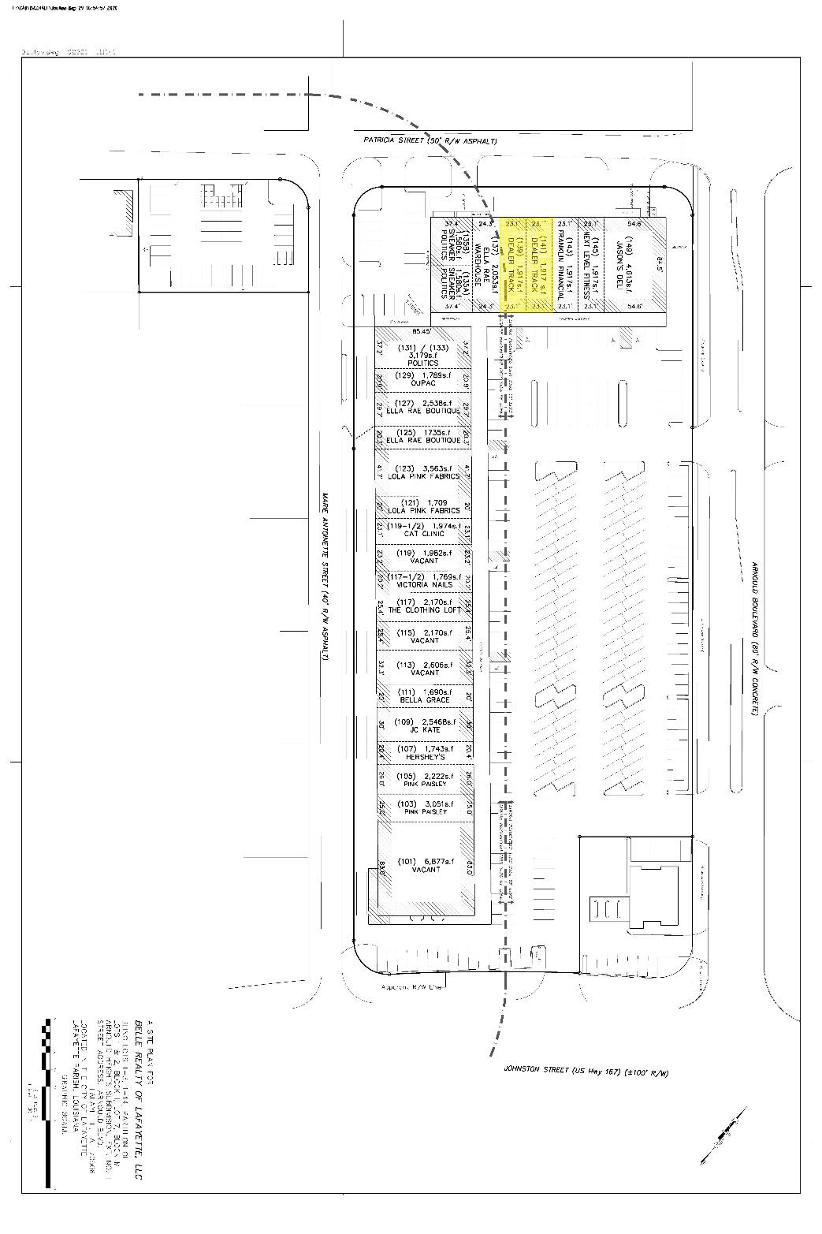

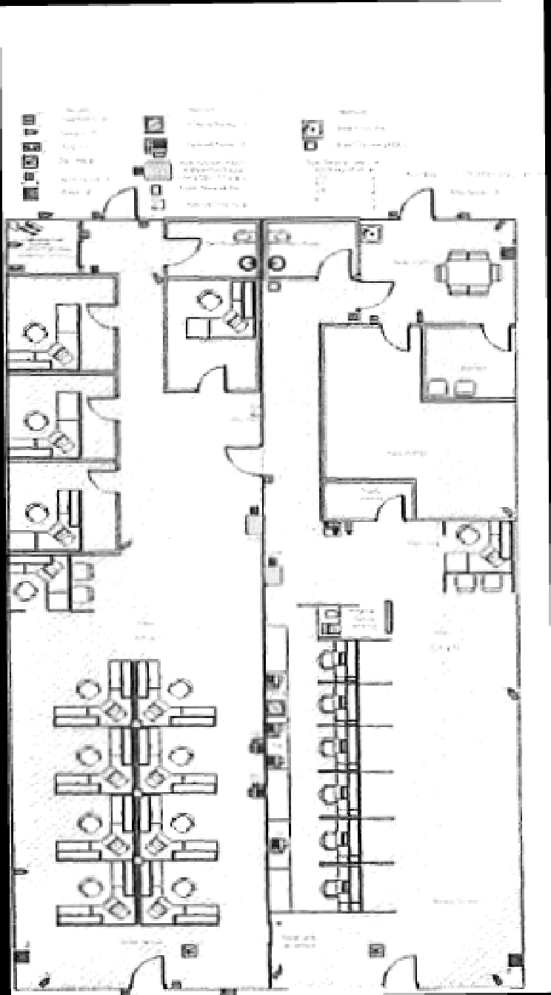

SCHEDULE B

BOULEVARD SHOPPING CENTER PROPERTY

SITE PLAN SHOWING COMMON AREA

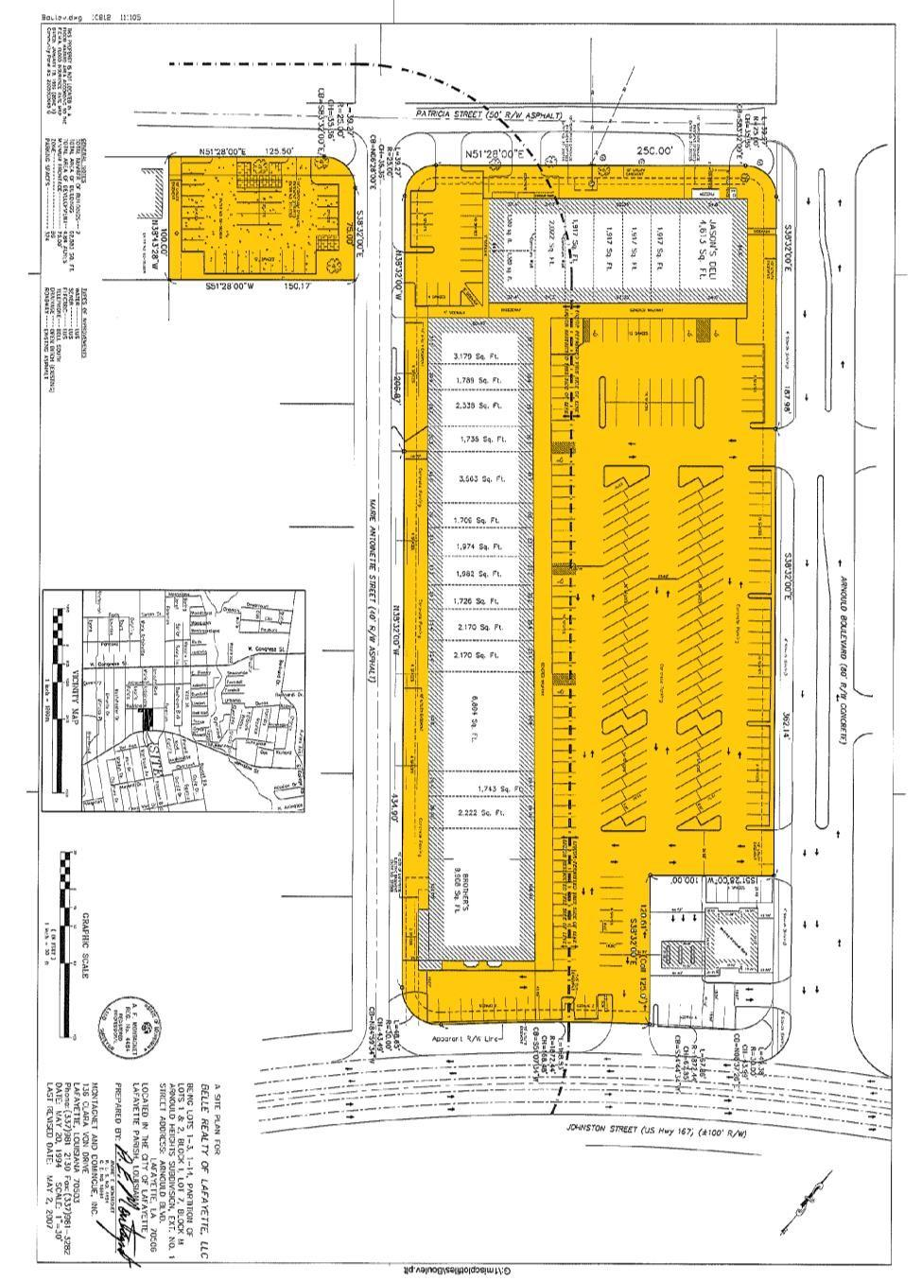
SCHEDULE C

THE BOULEVARD SHOPPING CENTER PROPERTY RULES AND REGULATIONS

All loading and unloading of goods shall be done only at such times, in the areas, and through the entrances, designated for such purposes by Lessor.

The delivery or shipping of merchandise, supplies, and fixtures to and from the Premises shall be subject to such rules and regulations, which in the sole judgment of Lessor are necessary for the proper operation of the Premises or the Boulevard Shopping Center (the “Shopping Center”).

All garbage and refuse shall be kept in the kind of container or receptacle specified by Lessor, and shall be placed in the area outside of the Premises prepared for collection in the manner and at the times and places specified by Lessor.

No radio or television or other similar device shall be installed without first obtaining, in each instance, Lessor’s prior consent in writing. No aerial or antenna of any kind shall be erected on the roof or exterior walls of the Premises, the building in which the Premises is located or on the grounds of the Shopping Center, without, in each instance, the prior written consent of the Lessor. Any aerial or antenna so installed without such written consent shall be subject to removal by the Lessor without notice at any time.

No loud speakers, televisions, phonographs, radios, or other devices shall be used in a manner so as to be heard or seen outside of the Premises without the prior written consent of Lessor.

If the Premises are equipped with heating facilities separate from those in the remainder of the Shopping Center, Lessee, during winter months shall keep the Premises heated at a temperature sufficient to prevent freezing of water in pipes and fixtures located within the Premises.

The exterior areas immediately adjoining the Premises shall be kept clean and free from snow, ice, dirt, trash, refuse and rubbish by Lessee to the satisfaction of Lessor, and Lessee shall not place or permit any obstruction or merchandise in such areas.

The plumbing facilities within the Premises shall not be used for any other purpose than that for which they are designed, and no foreign substance of any kind shall be thrown therein, and the expense of any breakage, stoppage, or damage resulting from a violation of this provision shall be borne by Lessee.

Lessee shall use, at Lessee’s cost, a qualified pest extermination contractor, whose services shall be scheduled so as not to reasonably interfere with the operation of the Shopping Center.

Lessee shall not burn any trash or garbage of any kind in or about the Premises, the Shopping Center, or within one mile of the outside property lines of the Shopping Center.

Lessee and Lessee’s employees shall park their cars only in those parking areas designated for that purpose by Lessor.

Lessee shall not make noises, cause disturbances, or create odors, which may be offensive to other tenants of the Shopping Center or their officers, employees, agents, servants, customers or invitees.

Lessee shall not place any type or kind of electrical power extension cord or light fixture outside of the Premises. The Lessee shall use only UL approved, ground faulted power strips to facilitate electrical power sources within the Premises.

Lessee shall not, without the prior written consent of the Lessor, hang or cause to be hung, any banner, sign, display or any other items of any kind outside of the Premises (including the lattice which is part of the building in which the Premises is located).

Lessee shall not, without the prior written consent of the Lessor, stand, erect, construct or otherwise place any display or any other thing of any kind whatsoever in front of the Premises.

Lessee’s business operation located within the Premises shall be open for business a minimum of five (5) days per each calendar week, Monday through and including Friday. In addition, such business operation shall be open during those days at least from 10:00 a.m. each day to 5:00 p.m. each day. Nothing contained herein shall prevent the Lessee from opening for business on Saturday or Sunday of each calendar week. In the event the Lessee’s business operations do not, for any reason, remain open for retail business as set forth herein, the Lessee shall be subject to a fine by the Lessor in any amount not to exceed $100.00 for each occurrence. Further provided, in the event of five (5) or more such occurrences within any twelve (12) month period, the Lessor shall have the right, in addition to all other remedies contained herein to terminate this Agreement. Notwithstanding anything contained herein to the contrary, the Lessee shall not be obligated to be open for business on the following holidays: New Years Day, Mardi Gras Day, Easter Sunday, Thanksgiving Day and Christmas Day.

In the event the Lessee displays any clock or other time keeping device on the Premises which is visible from the exterior, the same shall be maintained in a manner to display the accurate time at all times, including the adjustment of such time to reflect daylight savings time and standard time and to compensate for any power outages which may have affected such clock or time keeping device.

In the event the Lessee displays or otherwise employs a sign which is lighted by electrical current or otherwise, then the Lessee shall ensure that such signs are lighted as of dusk each day (adjusted for seasonal changes in such time) and remain lighted until midnight each day.

Lessee shall cause its name and address to be placed on the rear door of the Premises and shall, at its own expense, provide for security lighting to be placed on or about the rear door, which security lighting shall remain illuminated all night, every night.

Lessee shall not, nor shall Lessee permit any of its employees, contractors, customers or invitees to, solicit business or otherwise from any person or persons located on the Shopping Center property. Further, Lessee shall not respond or otherwise encourage or facilitate the solicitation by any outside person or persons on the Shopping Center property.

SCHEDULE D

DESIGN CRITERIA FOR LESSEE SIGNS

AT THE BOULEVARD SHOPPING CENTER

Lessee’s sign or signs shall be store identity signs only, and must be placed on the exterior façade of the canopy which covers the sidewalk in front of the Premises (the “Canopy”) in the area designated for signs. No signs shall be suspended from the underside of the façade, but may, subject to the approval of the Lessor, be suspended from the underside of the Canopy.

No freestanding signs shall be permitted.

Lessee’s signage shall be manufactured by Universal Sign Company and be Individual Channel Illuminated letters, interior light with single 12mm white neon, five and one-half (5 ½”) inch deep Channel letters using .040 aluminum with bronze factory baked enamel finish, plastic facing, using 1” Jewelite gold Trim cap.

Letter style may be of the Lessee’s choice, subject to review and written approval by Lessor prior to the sign order being placed with the company.

Lessee’s sign shall be limited to letters not to exceed twenty-six (26”) inches in height. The maximum length of Lessee’s lettering may be 80% of the frontage of the Premises, but no letters shall be nearer than two (2’) feet to either corner of the Premises. No exposed neon light shall be used on signs without Lessor’s prior written approval.

All neon on interior of letters to be UL48 specifications, PK housing, electrical conduit, etc. Letters to be mounted on a raceway, shall not exceed store identity name with cabinet being a maximum eight (8”) inches width and eight (8”) inches depth (transformers mounted in raceway); the raceway shall be painted the same color of the building fascia to which it will be attached.

Lessee’s lettering on doors, windows or show windows may not be illuminated and may not exceed six (6”) inches in height.

Lessee’s shall not employ paper signs to be applied to the interior or exterior faces of the store front glass or other material. Lessee shall not employ any flashing action, moving action or audible signs.

Lessee’s sign shall be in accordance with ordinances of governing bodies having jurisdiction over the Shopping Center, the Premises and/or the Lessee.

Lessee’s signs shall operate in a manner which automatically turns the sign(s) on at dusk and turns the sign(s) off at 12:00 midnight each day.

Lessor’s approval of Lessee’s plans and specifications for space improvement work shall not be deemed to constitute approval by Lessor of any of Lessee’s sign work. Lessee shall submit separate drawings and specifications, in quadruplicate, including colors, for all it’s proposed sign work. The drawings shall clearly show the location of all signs on the storefront elevation drawing, graphic, color and construction and attachment details. Within a reasonable time after the receipt of such drawings and specifications, Lessor shall return one set thereof to Lessee with its approval and/or any suggested modifications from Lessor. Lessee shall be deemed to have agreed to and approved all suggested modifications.

All Lessee signs must be fully approved in writing by Lessor prior to installation.

In the event that Lessee places or otherwise erects a sign or signs in any place other than within the Premises without the prior written approval of the Lessor, the Lessor shall have the right to remove such sign or signs and the costs or removal shall be the responsibility of the Lessee. The Lessee shall reimburse the Lessor for such costs within five (5) days of receipt of an invoice from the Lessor for the costs of removal of the sign or signs. The cost of such removal shall be considered rent due hereunder and the non-payment by the Lessee shall be considered nonpayment of rent and entitle the Lessor the exercise its rights for non-payment of rent.

GUARANTY

This Guaranty (“Guaranty”) is entered into as of the ____________day of ____________2021, by the undersigned (the “Guarantor” whether one or more), for the benefit of BELLE REALTY OF LAFAYETTE, L.L.C., a Louisiana limited liability company (the “Lessor”).

R E C I T A L S

- ALLIANCE SAFETY COUNCIL, a Louisiana non-profit organiztaion, whose mailing address during the term of this Lease shall be __10099 N. Reiger Rd. Baton Rouge, LA 70809_______________, and who is being represented herein by its _President and CEO____, (the “Lessee”), has entered into a certain Lease Agreement of even date herewith (“Lease”) by and between Lessor and Lessee, a copy of which is attached hereto as Exhibit A.

- Guarantor has an economic interest in Lessee or will otherwise obtain a material financial benefit from the Lease.

- As a condition to entering into the Lease with Lessee, Lessor requires that the Guarantor execute this Guaranty.

NOW, THEREFORE, in order to induce Lessor to enter into the Lease with the Lessee, and in consideration thereof, Guarantor agrees as follows:

- Capitalized terms used but not defined in this Guaranty shall have the meanings assigned to them in the Lease.

- Guarantor hereby absolutely, unconditionally and irrevocably guarantees to Lessor the full and prompt payment when due, whether at maturity or earlier, and at all times until this Guaranty is terminated or released under the terms hereof, and the full and prompt performance when due, of all of the following:

  - The payment, by the Lessee, when due, of all amounts due under the Lease.

  - The prompt performance of or compliance with any covenant or agreement contained in the Lease by the Lessee and the prompt performance by the Lessee of all of its obligations pursuant to the terms and conditions of the Lease.

  - All costs and expenses, including reasonable fees and out of pocket expenses of attorneys and expert witnesses, incurred by Lessor in enforcing its rights under this Guaranty.

- Guarantor’s obligations under this Guaranty constitute an unconditional guaranty of payment and performance and not merely a guaranty of collection.

- The obligations of Guarantor under this Guaranty shall be performed without demand by Lessor and shall be unconditional and without regard to any other circumstance which might otherwise constitute a legal or equitable discharge of a surety or a guarantor. Guarantor hereby waives the benefit of all principles or provisions of law, statutory or otherwise, which are or might be in conflict with the terms of this Guaranty and agrees that Guarantor’s obligations shall not be affected by any circumstances, whether or not referred to in this Guaranty, which might otherwise constitute a legal or equitable discharge of a surety or a guarantor. Guarantor hereby waives the benefits of any right of discharge under any and all statutes or other laws relating to guarantors or sureties and any other rights of sureties and guarantors thereunder. Without limiting the generality of the foregoing, Guarantor hereby waives, to the fullest extent permitted by law, diligence in collecting by the Lessor, presentment, demand for payment, protest, all notices with respect to the Lease and this Guaranty which may be required by statute, rule of law or otherwise to preserve Lessor’s rights against Guarantor under this Guaranty, including notice of acceptance, notice of any amendment of the Lease, notice of the occurrence of any default under the Lease, notice of dishonor and notice of protest. Guarantor also waives, to the fullest extent permitted by law, all rights to require Lessor to (a) proceed against Lessee (b) proceed against or exhaust any collateral held by Lessor to secure the performance of Lessee under the Lease, or (c) pursue any other remedy it may now or hereafter have against Lessee. In addition, Guarantor waives the benefit of any right of discharge under Louisiana law and all other rights of sureties and guarantors thereunder.

- At any time or from time to time and any number of times, without notice to Guarantor and without affecting the liability of Guarantor, (a) the time for payment of the amounts due under the Lease may be extended or the Lease may be renewed in whole or in part; or (b) the time for Lessee’s performance of or compliance with any covenant or agreement contained in the Lease, whether presently existing or hereinafter entered into, may be extended or such performance or compliance may be waived.

- Guarantor shall have no right of, and hereby waives any claim for, subrogation or reimbursement against Lessee by reason of any payment by Guarantor under this Guaranty, whether such right or claim arises at law or in equity or under any contract or statute, until all amounts due under the Lease have been paid in full and there has expired the maximum possible period thereafter during which any payment made by Lessee to Lessor with respect to the Lease could be deemed a preference under the United States Bankruptcy Code.

- If any payment by Lessee is held to constitute a preference under any applicable bankruptcy, insolvency, or similar laws, or if for any other reason Lessor is required to refund any sums to Lessee, such refund shall not constitute a release of any liability of Guarantor under this Guaranty. It is the intention of Lessor and Guarantor that Guarantor’s obligations under this Guaranty shall not be discharged except by Guarantor’s performance of such obligations and then only to the extent of such performance.

- Guarantor shall from time to time, upon request by Lessor, deliver to Lessor such financial statements as Lessor may reasonably require.

- Lessor may assign its rights under this Guaranty in whole or in part and, upon any such assignment, all the terms and provisions of this Guaranty shall inure to the benefit of such assignee to the extent so assigned. The terms used to designate any of the parties herein shall be deemed to include the heirs, legal representatives, successors and assigns of such parties.

- THIS GUARANTY AND THE LEASE REPRESENT THE FINAL AGREEMENT BETWEEN THE PARTIES AND MAY NOT BE CONTRADICTED BY EVIDENCE OF PRIOR, CONTEMPORANEOUS OR SUBSEQUENT ORAL AGREEMENTS. THERE ARE NO UNWRITTEN ORAL AGREEMENTS BETWEEN
THE PARTIES. All prior or contemporaneous agreements, understandings, representations, and statements, oral or written, are merged into this Guaranty and the Lease. Guarantor acknowledges that it has received a copy of the Lease. Neither this Guaranty nor any of its provisions may be waived, modified, amended, discharged, or terminated except by an agreement in writing signed by the party against which the enforcement of the waiver, modification, amendment, discharge, or termination is sought, and then only to the extent set forth in that agreement.

- Guarantor agrees that any controversy arising under or in relation to this Guaranty shall be litigated exclusively in Lafayette, Lafayette Parish, Louisiana (the “Property Jurisdiction”). The state and federal courts and authorities with jurisdiction in the Property Jurisdiction shall have exclusive jurisdiction over all controversies which shall arise under or in relation to this Guaranty and the Lease. Guarantor irrevocably consents to service, jurisdiction, and venue of such courts for any such litigation and waives any other venue to which it might be entitled by virtue of domicile, habitual residence or otherwise.

IN WITNESS WHEREOF, Guarantor has signed and delivered this Guaranty or has
caused this Guaranty to be signed and delivered by its duly authorized representative as of the date set forth above.

GUARANTOR:

_______________________
___________________________ (XXX-XX-______)
Address: _________________________________
________________________________________
Email: ____________________________________
Telephone: _______________________________

EXHIBIT A

THE BOULEVARD SHOPPING CENTER
LEASE AGREEMENT

